

Cairo University
Faculty of Engineering
Electronics and Electrical Communications Engineering

Assignment 1
ELC 4028 - Artificial Neural Networks

ID | Sec | Name
9220399 | 2 | شهد جمال محمود حسين
9220411 | 2 | صلاح الدين حسن حسن محمد
9220984 | 4 | يوسف خالد عمر محمود

Supervised by:
Dr. Mohsen Rashwan
Dr. Mohamed Motaz

Table of Content:

Table of Content: 2

Table of Figures: 3

PART1 : Regressing Problems 5
Problem 1: Insurance Company 5
1.1 Dataset 5
1.2 Case A: WITH Outlier 5
1. Scatter Plot & Outlier Identification 5
2. Regression Models (WITH Outlier) 6
2.1 Linear Model 6
➢ Hand Analysis (OLS Method) 6
➢ Hand Analysis (Matrix Form) 7
➢ R² Verification Table 8
➢ Output Graph 9
➢ Simulation Results: 9
2.2 Quadratic Model 10
➢ Hand Analysis (Matrix Form) 10
➢ R² Verification Table 10
➢ Output Graph 11
➢ Simulation Results: 12
2.3 Cubic Model 12
➢ Hand Analysis (Matrix Form) 12
➢ R² Verification Table 12
➢ Output Graph 13
➢ Simulation Results: 14
3. Comparison between three models (WITH Outlier): 14
1.3 Case B: WITHOUT Outlier 15
1. Outlier Removal and Scatter Plot of Cleaned Data 15
2. Regression Models (WITHOUT Outlier) 15
2.1 Linear Model 15
➢ Hand Analysis (OLS Method) 15
➢ Hand Analysis (Matrix Form) 16
➢ R² Verification Table 17
➢ Output Graph 17
➢ Simulation Results: 18
2.2 Quadratic Model 18
➢ Hand Analysis (Matrix Form) 18
➢ R² Verification Table 19
➢ Output Graph 20
➢ Simulation Results: 20
2.3 Cubic Model 21
➢ Hand Analysis (Matrix Form) 21
➢ R² Verification Table 21
➢ Output Graph 22
➢ Simulation Results: 23
1.3 Comparison Between Three Models (Cleaned Data): 23
1.4 Best-Fit Model Selection 24
1.5 Prediction of Insured People 25
Problem 2: Heating Oil 26
2.1 Dataset 26
2.2 Case A: WITH Outlier 26
1. Scatter Plot & Outlier Identification 26
2. Regression Models 28
2.1 Linear Model 28
2.2 Quadratic Model 29
2.3 Case B: WITHOUT Outlier 30
1. Scatter Plot & Outlier Identification (WITHOUT Outlier) 30
2. Regression Models (WITHOUT Outlier) 31
2.1 Linear Model 31
2.2 Quadratic Model 32
2.4 Comparison of Models and Best-Fit Selection 33
2.5 Prediction of Oil 34

Table of Figures:
Figure 1: Scatter plot of original dataset identifying the outlier at x = 3 (y = 1050) 6
Figure 2: Linear Model of Original Data with Outlier 9
Figure 3: Simulation Results of Linear Model of Original Data with Outlier 9
Figure 4: Quadratic Model of Original Data with Outlier 11
Figure 5: Simulation Results of Quadratic Model of Original Data with Outlier 12
Figure 6: : Simulation Results of Cubic Model of Original Data with Outlier 14
Figure 7: Comparison between three Models of Original Data with Outlier 14
Figure 8: Scatter Plot of Cleaned Data without Outlier 15
Figure 9: Linear Model of Cleaned Data without Outlier 18
Figure 10: Simulation Results of Linear Model of Cleaned Data without Outlier 18
Figure 11: Quadratic Model of Cleaned Data without Outlier 20
Figure 12: Simulation Results of Quadratic Model of Cleaned Data without Outlier 20
Figure 13:Cubic Model of Cleaned Data without Outlier 22
Figure 14: Simulation Results of Cubic Model of Cleaned Data without Outlier 23
Figure 15: Comparison between three Models of Cleamed Data without Outlier 23
Figure 16: R-square Comparison between three Models 24
Figure 17: Best Fit Model with Outlier 25
Figure 18: Best Fit Model without Outlier 25
Figure 19: Simulation Results of Best Fit Model with Outlier 25
Figure 20: SImulation Results of Best Fit Model without Outlier 25
Figure 21: Simulation Results of Predection Insured People at year 1997 26
Figure 22: 3D Scatter Plot to Detect Outlier (outlier in red: Insulation=40) 27
Figure 23: 3D Linear Regression Surface (With Outlier), R² = 0.6967 28
Figure 24: Simulation Results of Linear Regression Surface (With Outlier) 28
Figure 25: 3D Quadratic Regression Surface (With Outlier), R² = 0.9742 29
Figure 26: Simulation Results of Quadratic Regression Surface (With Outlier) 29
Figure 27: 3D Scatter Plot (Cleaned Data, Outlier Removed) 30
Figure 28: 3D Linear Regression Surface (Cleaned Data), R² = 0.9606 31
Figure 29: Simulation Results of Linear Regression Surface (Cleaned Data) 31
Figure 30: 3D Quadratic Regression Surface (Cleaned Data), R² = 0.9769 32
Figure 31: Simulation Results of Quadratic Regression Surface (Cleaned Data) 32
Figure 32: Best Fit Model of Cleaned Data (Linear Model) 33
Figure 33: Best Fit Model of Original Data (Quadratic Model) 33
Figure 34: Simulation Results of Best Fit Model 34
Figure 35: Simulation Results of Prediction Oil of Cleaned Data 34
Figure 36: Simulation Results of Prediction Oil of Original Data 35

PART1 : Regressing Problems

Problem 1: Insurance Company
The numbers of insured persons y with an insurance company for the years 1987 to 1996 are given. We let x represent the number of years since 1987 (x = 0 for 1987, x = 9 for 1996).

1.1 Dataset
x (years since 1987) | Year | y (insured persons)
0 | 1987 | 12,400
1 | 1988 | 10,900
2 | 1989 | 10,000
3 | 1990 | 1,050 (OUTLIER)
4 | 1991 | 9,500
5 | 1992 | 8,900
6 | 1993 | 8,000
7 | 1994 | 7,800
8 | 1995 | 7,600
9 | 1996 | 7,200
* Value 1050 at x = 3 (year 1990) is the outlier — likely a data entry error or anomaly.

1.2 Case A: WITH Outlier

1. Scatter Plot & Outlier Identification
A scatter plot of y (number of insured persons) versus x (years since 1987) reveals a generally decreasing trend from ~12,400 down to ~7,200. However, one data point stands out sharply:
- x = 3 (year 1990): y = 1050
This value is dramatically lower than the surrounding data , which are all within the range of approximately 7,200 to 12,400. The sharp drop at this point breaks the otherwise smooth downward trend.
Therefore, this observation is identified as a clear outlier, most likely due to a data entry error (for example, a missing digit such as 10,500 instead of 1,050).

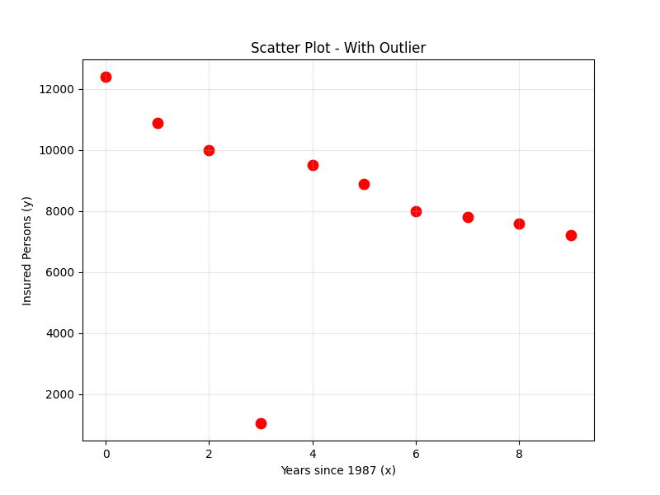
Figure 1: Scatter plot of original dataset identifying the outlier at x = 3 (y = 1050)

2. Regression Models (WITH Outlier)
We apply both OLS and matrix-form methods to compute linear model parameters, then use the matrix form for quadratic and cubic models.

2.1 Linear Model

Hand Analysis (OLS Method)
The equation for the linear model is given as follows:

$$\hat{y_{i}}=β_{0}+β_{1}x_{i}$$

The key formulas used are:

$\hat{β_{1}}=\frac{\sum_{i=i}^{n}{x_{i}y_{i}} - \frac{\left(\sum_{i=1}^{n}{x_{i}}\right)\left(\sum_{i=1}^{n}{y_{i}}\right)}{n}}{\sum_{i=1}^{n}{x_{i}^{2 }}- \frac{{\left(\sum_{i=1}^{n}{x_{i}}\right)}^{2}}{n}}$ , $\hat{β_{0}}=\hat{y} - \hat{β_{i}}x$
Data Table for Hand Computation:

year | xᵢ | yᵢ | xᵢ² | yᵢ² | xᵢyᵢ
1987 | 0 | 12400 | 0 | 153,760,000 | 0
1988 | 1 | 10900 | 1 | 118,810,000 | 10,900
1989 | 2 | 10000 | 4 | 100,000,000 | 20,000
1990 | 3 | 1050 | 9 | 1,102,500 | 3,150
1991 | 4 | 9500 | 16 | 90,250,000 | 38,000
1992 | 5 | 8900 | 25 | 79,210,000 | 44,500
1993 | 6 | 8000 | 36 | 64,000,000 | 48,000
1994 | 7 | 7800 | 49 | 60,840,000 | 54,600
1995 | 8 | 7600 | 64 | 57,760,000 | 60,800
1996 | 9 | 7200 | 81 | 51,840,000 | 64,800
Σ = | 45 | 83,350 | 285 | 777,572,500 | 344,750

$n = 10$ , $y=\frac{83350}{10}=8335$ , $x=\frac{45}{10}=4.5$

$\hat{β_{1}}=\frac{344,750 - \frac{45 * 83,350 }{10}}{285- \frac{{45}^{2}}{10}}$ $= - 367.57$

$$\hat{β_{0}}=8335 +367.57 * 4.5=9989.09$$

Hand Analysis (Matrix Form)

$$β={(X^{T}X)}^{-1}X^{T}Y$$

$$β= \left(\begin{matrix}β_{0} \\ β_{1}\end{matrix}\right) , X=\left(\begin{matrix}1 & 0 \\ 1 & 1 \\ 1 & 2 \\ 1 & 3 \\ 1 & 4 \\ 1 & 5 \\ 1 & 6 \\ 1 & 7 \\ 1 & 8 \\ 1 & 9\end{matrix}\right) , Y =\left(\begin{matrix}12400 \\ 10900 \\ 10000 \\ 1050 \\ 9500 \\ 8900 \\ 8000 \\ 7800 \\ 7600 \\ 7200\end{matrix}\right)$$

$$\left(\begin{matrix}β_{0} \\ β_{1}\end{matrix}\right)=\left(\begin{matrix}9989.09 \\ -367.576\end{matrix}\right)$$

So ,linear equation is:
$$\hat{y_{i}}= 9989.09-367.576 x$$

R² Verification Table
$$\overline{y}=\frac{\sum_{i=1}^{n}{y_{i}}}{n}=\frac{83350}{10}=8335$$

year | xᵢ | yᵢ | ŷᵢ = $β_{0}+β_{1}x_{i}$ | SSE = (yᵢ − ŷᵢ)² | SSyy = (yᵢ − ȳ)²
1987 | 0 | 12400 | 9,989.1 | 5,812,483 | 16,524,225
1988 | 1 | 10900 | 9,621.5 | 1,634,524 | 6,579,225
1989 | 2 | 10000 | 9,253.9 | 556,606 | 2,772,225
1990 | 3 | 1050 | 8,886.4 | 61,408,600 | 53,071,225
1991 | 4 | 9500 | 8,518.8 | 962,777 | 1,357,225
1992 | 5 | 8900 | 8,151.2 | 560,683 | 319,225
1993 | 6 | 8000 | 7,783.6 | 46,813 | 112,225
1994 | 7 | 7800 | 7,416.1 | 147,410 | 286,225
1995 | 8 | 7600 | 7,048.5 | 304,169 | 540,225
1996 | 9 | 7200 | 6,680.9 | 269,455 | 1,288,225
Σ = | 45 | 83,350 | 83,350 | 71,703,515 | 82,850,250

$$R_{linear model}^{2} = \frac{SS - SSE}{SS} = \frac{82,850,250 - 71,703,515}{82,850,250} = 0.13454$$

Output Graph
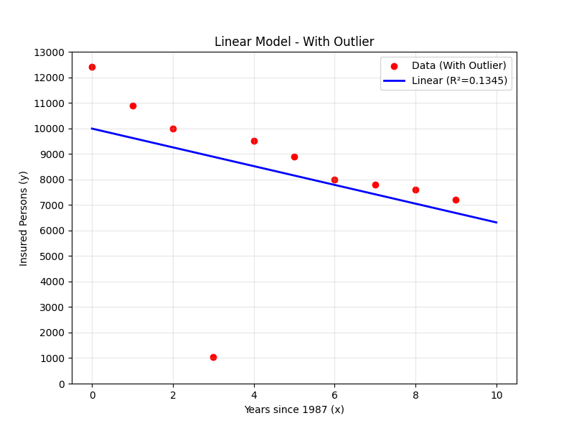
Figure 2: Linear Model of Original Data with Outlier

Simulation Results:

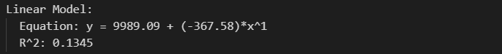
Figure 3: Simulation Results of Linear Model of Original Data with Outlier

2.2 Quadratic Model
The equation for the quadratic model is given as follows:

$$\hat{y_{i}}=β_{0}+β_{1}x_{i}+{β_{2}x}_{i}^{2}$$

Hand Analysis (Matrix Form)

$$β={(X^{T}X)}^{-1}X^{T}Y$$

$$β= \left(\begin{matrix}β_{0} \\ β_{1} \\ β_{2}\end{matrix}\right) , X=\left(\begin{matrix}1 & 0 & 0^{2} \\ 1 & 1 & 1^{2} \\ 1 & 2 & 2^{2} \\ 1 & 3 & 3^{2} \\ 1 & 4 & 4^{2} \\ 1 & 5 & 5^{2} \\ 1 & 6 & 6^{2} \\ 1 & 7 & 7^{2} \\ 1 & 8 & 8^{2} \\ 1 & 9 & 9^{2}\end{matrix}\right) , Y =\left(\begin{matrix}12400 \\ 10900 \\ 10000 \\ 1050 \\ 9500 \\ 8900 \\ 8000 \\ 7800 \\ 7600 \\ 7200\end{matrix}\right)$$

$$\left(\begin{matrix}β_{0} \\ β_{1} \\ β_{2}\end{matrix}\right)=\left(\begin{matrix}11627.73 \\ -1596.55 \\ 136.55\end{matrix}\right)$$

So ,linear equation is:
$$\hat{y_{i}}=11627.73-1596.55x+136.55x^{2}$$

R² Verification Table

$$\overline{y}=\frac{\sum_{i=1}^{n}{y_{i}}}{n}=\frac{83350}{10}=8335$$

year | xᵢ | yᵢ | ŷᵢ = $β_{0}+β_{1}x_{i}+{β_{2}x}_{i}^{2}$ | SSE = (yᵢ − ŷᵢ)² | SSyy = (yᵢ − ȳ)²
1987 | 0 | 12400 | 11,627.7 | 596,405 | 16,524,225
1988 | 1 | 10900 | 10,167.7 | 536,223 | 6,579,225
1989 | 2 | 10000 | 8,980.8 | 1,038,701 | 2,772,225
1990 | 3 | 1050 | 8,067.0 | 49,238,925 | 53,071,225
1991 | 4 | 9500 | 7,426.4 | 4,299,969 | 1,357,225
1992 | 5 | 8900 | 7,058.8 | 3,390,064 | 319,225
1993 | 6 | 8000 | 6,964.3 | 1,072,639 | 112,225
1994 | 7 | 7800 | 7,143.0 | 431,710 | 286,225
1995 | 8 | 7600 | 7,594.7 | 28 | 540,225
1996 | 9 | 7200 | 8,319.5 | 1,253,377 | 1,288,225
Σ = | 45 | 83,350 | 83,350 | 61,858,042 | 82,850,250

$$R_{quad model}^{2} = \frac{SS - SSE}{SS} =\frac{82,850,250- 61,858,042}{82,850,250}=0.2534$$

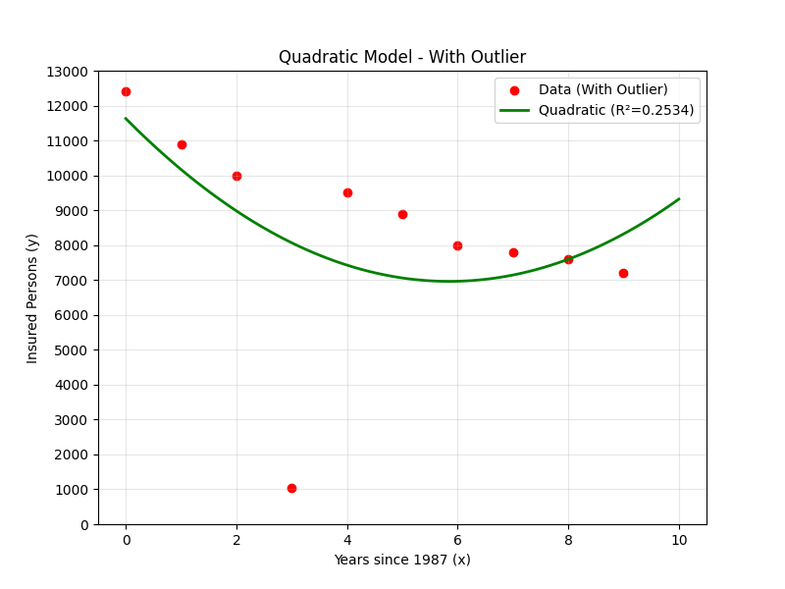
Output Graph
Figure 4: Quadratic Model of Original Data with Outlier

Simulation Results:
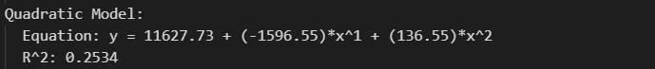
Figure 5: Simulation Results of Quadratic Model of Original Data with Outlier

2.3 Cubic Model
The equation for the cubic model is given as follows:

$$\hat{y_{i}}=β_{0}+β_{1}x_{i}+{β_{2}x}_{i}^{2}+{β_{3}x}_{i}^{3}$$

Hand Analysis (Matrix Form)
$$β={(X^{T}X)}^{-1}X^{T}Y$$

$$β= \left(\begin{matrix}β_{0} \\ β_{1} \\ β_{2} \\ β_{3}\end{matrix}\right) , X=\left(\begin{matrix}1 & 0^{2} & 0^{3} \\ 1 & 1^{2} & 1^{3} \\ 1 & 2^{2} & 2^{3} \\ 1 & 3^{2} & 3^{3} \\ 1 & 4^{2} & 4^{3} \\ 1 & 5^{2} & 5^{3} \\ 1 & 6^{2} & 6^{3} \\ 1 & 7^{2} & 7^{3} \\ 1 & 8^{2} & 8^{3} \\ 1 & 9^{2} & 9^{3}\end{matrix}\right) , Y =\left(\begin{matrix}12400 \\ 10900 \\ 10000 \\ 1050 \\ 9500 \\ 8900 \\ 8000 \\ 7800 \\ 7600 \\ 7200\end{matrix}\right)$$

$$\left(\begin{matrix}β_{0} \\ β_{1} \\ β_{2} \\ β_{3}\end{matrix}\right)=\left(\begin{matrix}13113.15 \\ -4313.93 \\ 932.31 \\ -58.95\end{matrix}\right)$$

So ,linear equation is:
$$\hat{y_{i}}=13113.15-4313.93 x_{i}{ + 932.31 x}_{i}^{2} {- 58.95 x}_{i}^{3}$$

R² Verification Table
$$\overline{y}=\frac{\sum_{i=1}^{n}{y_{i}}}{n}=\frac{83350}{10}=8335$$

year | xᵢ | yᵢ | ŷᵢ = $β_{0}+β_{1}x_{i}+{β_{2}x}_{i}^{2}+{β_{3}x}_{i}^{3}$ | SSE = (yᵢ − ŷᵢ)² | SSyy = (yᵢ − ȳ)²
1987 | 0 | 12400 | 13,113.1 | 508,578 | 16,524,225
1988 | 1 | 10900 | 9,672.6 | 1,506,542 | 6,579,225
1989 | 2 | 10000 | 7,743.0 | 5,094,123 | 2,772,225
1990 | 3 | 1050 | 6,970.7 | 35,054,266 | 53,071,225
1991 | 4 | 9500 | 7,002.0 | 6,240,214 | 1,357,225
1992 | 5 | 8900 | 7,483.2 | 2,007,341 | 319,225
1993 | 6 | 8000 | 8,060.7 | 3,684 | 112,225
1994 | 7 | 7800 | 8,380.8 | 337,334 | 286,225
1995 | 8 | 7600 | 8,089.8 | 239,940 | 540,225
1996 | 9 | 7200 | 6,834.1 | 133,864 | 1,288,225
Σ = | 45 | 83,350 | 83,350 | 51,125,885 | 82,850,250

$$R_{cubic model}^{2} = \frac{SS - SSE}{SS} = \frac{82,850,250 -51,125,885}{82,850,250} = 0.3829$$

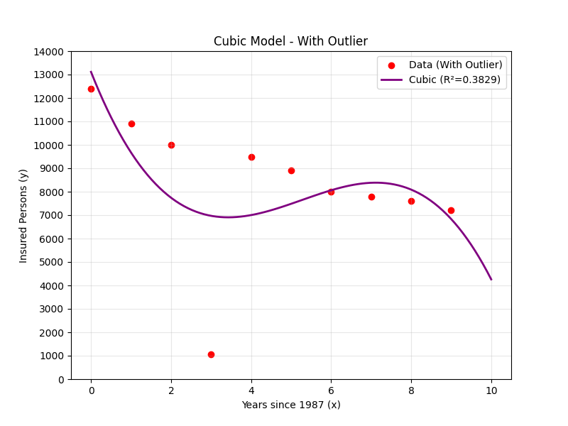
Output Graph
Figure: : Cubic Model of Original Data with Outlier

Simulation Results:
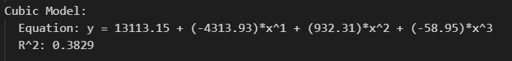
Figure 6: : Simulation Results of Cubic Model of Original Data with Outlier

3. Comparison between three models (WITH Outlier):
Model | Equation (MATLAB) | R²
Linear | $$\hat{y_{i}}= 9989.09-367.576 x_{i}$$ | 0.1345
Quadratic | $$\hat{y_{i}}=11627.73-1596.55{ x}_{i}+136.55 x_{i}^{2}$$ | 0.2534
Cubic | $$\hat{y_{i}}=13113.15-4313.93 x_{i}{ + 932.31 x}_{i}^{2} {- 58.95 x}_{i}^{3}$$ | 0.3829
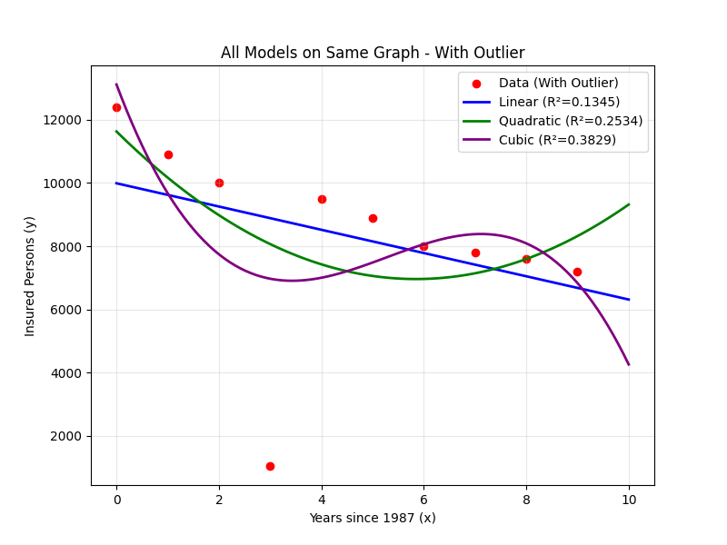
Figure 7: Comparison between three Models of Original Data with Outlier
Comment:
All R² values are low (< 0.50) due to the heavy influence of the outlier at x = 3 (y = 1050). The cubic model yields the highest R.

1.3 Case B: WITHOUT Outlier

1. Outlier Removal and Scatter Plot of Cleaned Data
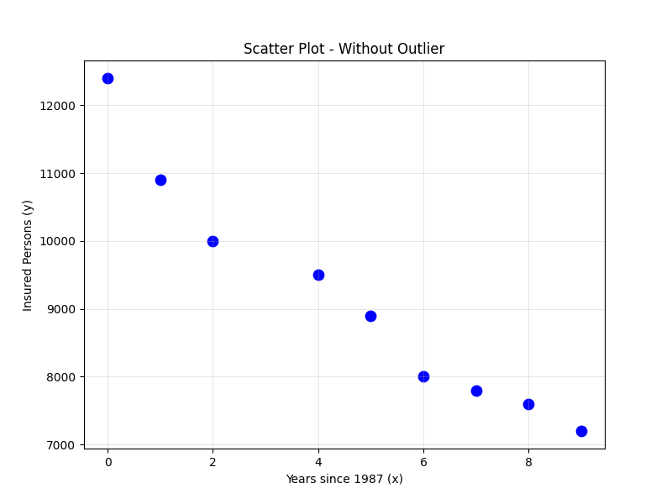
Figure 8: Scatter Plot of Cleaned Data without Outlier

2. Regression Models (WITHOUT Outlier)
After removing the outlier at x = 3 (y = 1,050), the cleaned dataset contains 9 data points. We now repeat the regression analysis using the same methods.

2.1 Linear Model

Hand Analysis (OLS Method)
The equation for the linear model is given as follows:

$$\hat{y_{i}}=β_{0}+β_{1}x_{i}$$

Data Table for Hand Computation:

year | xᵢ | yᵢ | xᵢ² | yᵢ² | xᵢyᵢ
1987 | 0 | 12,400 | 0 | 153,760,000 | 0
1988 | 1 | 10,900 | 1 | 118,810,000 | 10,900
1989 | 2 | 10,000 | 4 | 100,000,000 | 20,000
1991 | 4 | 9,500 | 16 | 90,250,000 | 38,000
1992 | 5 | 8,900 | 25 | 79,210,000 | 44,500
1993 | 6 | 8,000 | 36 | 64,000,000 | 48,000
1994 | 7 | 7,800 | 49 | 60,840,000 | 54,600
1995 | 8 | 7,600 | 64 | 57,760,000 | 60,800
1996 | 9 | 7,200 | 81 | 51,840,000 | 64,800
Σ = | 42 | 82,300 | 276 | 776,470,000 | 341,600

$n = 9$ , $y=\frac{82300}{9}=9,144.44$ , $x=\frac{42}{9}=4.667$

$\hat{β_{1}}=\frac{341,600 - \frac{42*82300 }{9}}{276- \frac{{42}^{2}}{9}}$ $= - 530.83$

$$\hat{β_{0}}=9,144.44 +530.83 * 4.667=11,621.67$$

Hand Analysis (Matrix Form)
$$β={(X^{T}X)}^{-1}X^{T}Y$$

$$β= \left(\begin{matrix}β_{0} \\ β_{1}\end{matrix}\right) , X=\left(\begin{matrix}1 & 0 \\ 1 & 1 \\ 1 & 2 \\ 1 & 4 \\ 1 & 5 \\ 1 & 6 \\ 1 & 7 \\ 1 & 8 \\ 1 & 9\end{matrix}\right) , Y =\left(\begin{matrix}12400 \\ 10900 \\ 10000 \\ 9500 \\ 8900 \\ 8000 \\ 7800 \\ 7600 \\ 7200\end{matrix}\right)$$

$$\left(\begin{matrix}β_{0} \\ β_{1}\end{matrix}\right)=\left(\begin{matrix} 11,621.67 \\ -530.83\end{matrix}\right)$$

So ,linear equation is:
$$\hat{y_{i}}=11,621.67 -530.83 x$$

R² Verification Table
$$\hat{y_{i}}=\frac{82300}{9}=9,144.44$$
year | xᵢ | yᵢ | ŷᵢ = $β_{0}+β_{1}x_{i}$ | SSE = (yᵢ − ŷᵢ)² | SSyy = (yᵢ − ȳ)²
1987 | 0 | 12400 | 11621.7 | 605,803 | 10,598,642
1988 | 1 | 10900 | 11090.8 | 36,417 | 3,081,975
1989 | 2 | 10000 | 10560.0 | 313,600 | 731,975
1991 | 4 | 9500 | 9498.3 | 3 | 126,420
1992 | 5 | 8900 | 8967.5 | 4,556 | 59,753
1993 | 6 | 8000 | 8436.7 | 190,678 | 1,309,753
1994 | 7 | 7800 | 7905.8 | 11,201 | 1,807,531
1995 | 8 | 7600 | 7375.0 | 50,625 | 2,385,309
1996 | 9 | 7200 | 6844.2 | 126,617 | 3,780,864
Σ = | 42 | 82,300 | 82300.0 | 1,339,500 | 23,882,222

$$R_{linear model}^{2} = \frac{SS - SSE}{SS} = \frac{23,882,222 - 1,339,500}{23,882,222} = 0.9439$$

Output Graph

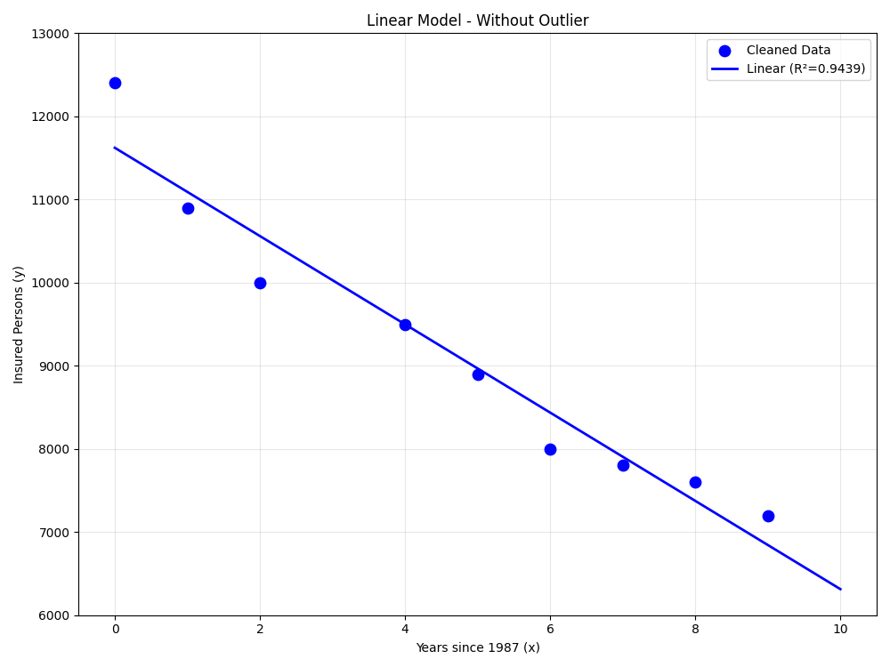
Figure 9: Linear Model of Cleaned Data without Outlier

Simulation Results:

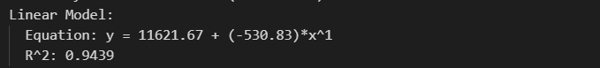
Figure 10: Simulation Results of Linear Model of Cleaned Data without Outlier

2.2 Quadratic Model
The equation for the quadratic model is given as follows:

$$\hat{y_{i}}=β_{0}+β_{1}x_{i}+{β_{2}x}_{i}^{2}$$

Hand Analysis (Matrix Form)

$$β={(X^{T}X)}^{-1}X^{T}Y$$

$$β= \left(\begin{matrix}β_{0} \\ β_{1} \\ β_{2}\end{matrix}\right) , X=\left(\begin{matrix}1 & 0 & 0^{2} \\ 1 & 1 & 1^{2} \\ 1 & 2 & 2^{2} \\ 1 & 4 & 4^{2} \\ 1 & 5 & 5^{2} \\ 1 & 6 & 6^{2} \\ 1 & 7 & 7^{2} \\ 1 & 8 & 8^{2} \\ 1 & 9 & 9^{2}\end{matrix}\right) , Y =\left(\begin{matrix}12400 \\ 10900 \\ 10000 \\ 9500 \\ 8900 \\ 8000 \\ 7800 \\ 7600 \\ 7200\end{matrix}\right)$$

$$\left(\begin{matrix}β_{0} \\ β_{1} \\ β_{2}\end{matrix}\right)=\left(\begin{matrix}12,024.17 \\ -863.13 \\ 37.44\end{matrix}\right)$$

So ,linear equation is:
$$\hat{y_{i}}=12,024.17 -863.13 x+37.44 x^{2}$$

R² Verification Table
$$\overline{y}=\frac{\sum_{i=1}^{n}{y_{i}}}{n}=\frac{82,300}{9}=9,144.44$$

year | xᵢ | yᵢ | ŷᵢ = $β_{0}+β_{1}x_{i}+{β_{2}x}_{i}^{2}$ | SSE = (yᵢ − ŷᵢ)² | SSyy = (yᵢ − ȳ)²
1987 | 0 | 12400 | 12024.2 | 141,248 | 10,598,642
1988 | 1 | 10900 | 11198.5 | 89,090 | 3,081,975
1989 | 2 | 10000 | 10447.7 | 200,411 | 731,975
1991 | 4 | 9500 | 9170.7 | 108,429 | 126,420
1992 | 5 | 8900 | 8644.6 | 65,249 | 59,753
1993 | 6 | 8000 | 8193.3 | 37,362 | 1,309,753
1994 | 7 | 7800 | 7816.9 | 286 | 1,807,531
1995 | 8 | 7600 | 7515.4 | 7,156 | 2,385,309
1996 | 9 | 7200 | 7288.8 | 7,884 | 3,780,864
Σ = | 42 | 82,300 | 82300.0 | 657,116 | 23,882,222

$$R_{quad model}^{2} = \frac{SS - SSE}{SS} =\frac{23,882,222- 657,116}{23,882,222}=0.9725$$

Output Graph
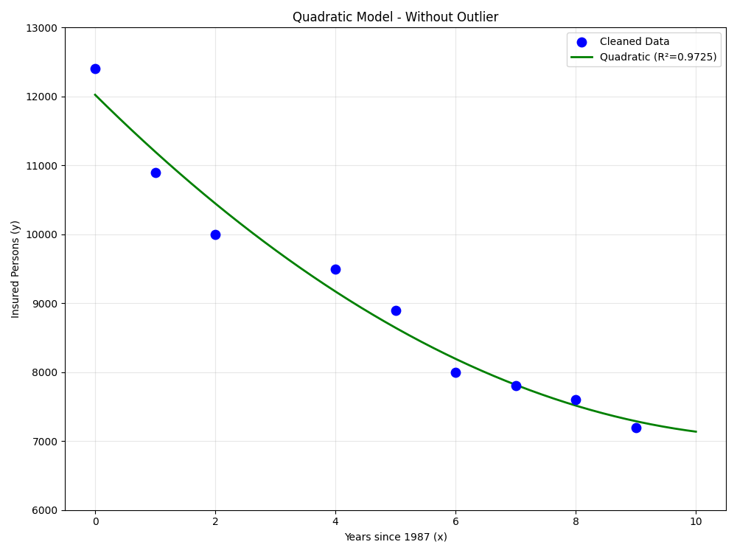
Figure 11: Quadratic Model of Cleaned Data without Outlier

Simulation Results:
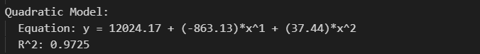
Figure 12: Simulation Results of Quadratic Model of Cleaned Data without Outlier

2.3 Cubic Model
The equation for the cubic model is given as follows:

$$\hat{y_{i}}=β_{0}+β_{1}x_{i}+{β_{2}x}_{i}^{2}+{β_{3}x}_{i}^{3}$$

Hand Analysis (Matrix Form)

$$β={(X^{T}X)}^{-1}X^{T}Y$$

$$β= \left(\begin{matrix}β_{0} \\ β_{1} \\ β_{2} \\ β_{3}\end{matrix}\right) , X=\left(\begin{matrix}1 & 0^{2} & 0^{3} \\ 1 & 1^{2} & 1^{3} \\ 1 & 2^{2} & 2^{3} \\ 1 & 4^{2} & 4^{3} \\ 1 & 5^{2} & 5^{3} \\ 1 & 6^{2} & 6^{3} \\ 1 & 7^{2} & 7^{3} \\ 1 & 8^{2} & 8^{3} \\ 1 & 9^{2} & 9^{3}\end{matrix}\right) , Y =\left(\begin{matrix}12400 \\ 10900 \\ 10000 \\ 9500 \\ 8900 \\ 8000 \\ 7800 \\ 7600 \\ 7200\end{matrix}\right)$$

$$\left(\begin{matrix}β_{0} \\ β_{1} \\ β_{2} \\ β_{3}\end{matrix}\right)=\left(\begin{matrix}12,204.42 \\ -1,221.74 \\ 140.17 \\ -7.46\end{matrix}\right)$$

So ,linear equation is:
$$\hat{y_{i}}=12,204.42 -1,221.74 x_{i}{ + 140.17 x}_{i}^{2} {- 7.46 x}_{i}^{3}$$

R² Verification Table
$$\overline{y}=\frac{\sum_{i=1}^{n}{y_{i}}}{n}=\frac{82,300 }{9}=9,144.44$$

year | xᵢ | yᵢ | ŷᵢ = $β_{0}+β_{1}x_{i}+{β_{2}x}_{i}^{2}+{β_{3}x}_{i}^{3}$ | SSE = (yᵢ − ŷᵢ)² | SSyy = (yᵢ − ȳ)²
1987 | 0 | 12400 | 12204.4 | 38,251 | 10,598,642
1988 | 1 | 10900 | 11115.4 | 46,392 | 3,081,975
1989 | 2 | 10000 | 10261.9 | 68,595 | 731,975
1991 | 4 | 9500 | 8666.9 | 174,339 | 126,420
1992 | 5 | 8900 | 8307.8 | 54,323 | 59,753
1993 | 6 | 8000 | 7960.3 | 94,746 | 1,309,753
1994 | 7 | 7800 | 7579.7 | 25,702 | 1,807,531
1995 | 8 | 7600 | 7121.1 | 413 | 2,385,309
1996 | 9 | 7200 | 82300.0 | 6,227 | 3,780,864
Σ = | 42 | 82,300 | 12204.4 | 508,988 | 23,882,222

$$R_{cubic model}^{2} = \frac{SS - SSE}{SS} = \frac{23,882,222 -508,988}{23,882,222} = 0.9787$$

Output Graph
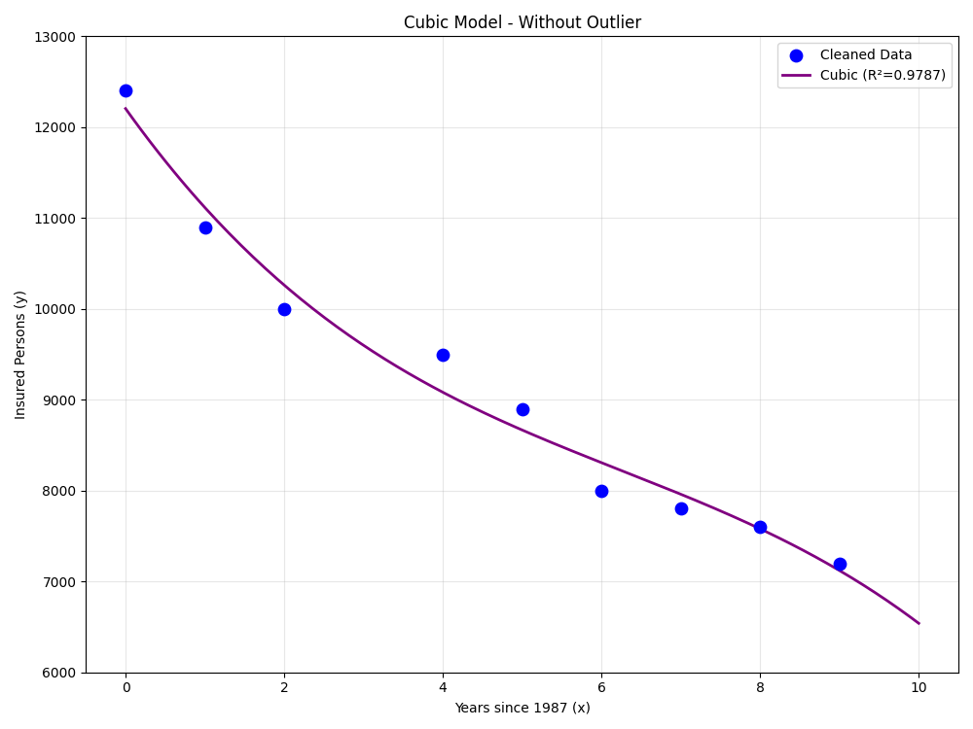
Figure 13:Cubic Model of Cleaned Data without Outlier

Simulation Results:
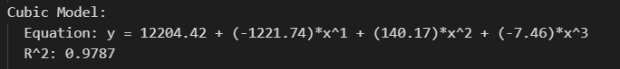
Figure 14: Simulation Results of Cubic Model of Cleaned Data without Outlier

1.3 Comparison Between Three Models (Cleaned Data):
Model | Equation (MATLAB) | R²
Linear | $$\hat{y_{i}}=11,621.67 -530.83 x$$ | 0.9439
Quadratic | $$\hat{y_{i}}=12,024.17 -863.13 x+37.44 x^{2}$$ | 0.9725
Cubic | $$\hat{y_{i}}=12,204.42 -1,221.74 x_{i}{ + 140.17 x}_{i}^{2} {- 7.46 x}_{i}^{3}$$ | 0.9787
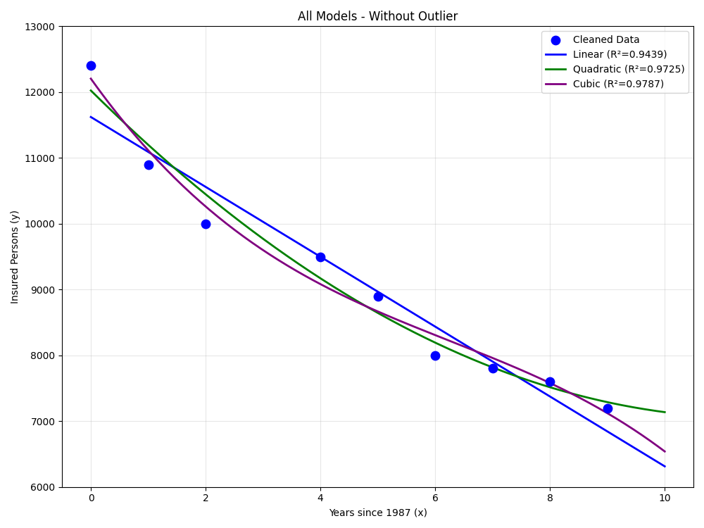
Figure 15: Comparison between three Models of Cleamed Data without Outlier
Comment:
All three R² values are very high (> 0.94) after removing the outlier, confirming that it was the primary source of distortion. The linear model alone explains 94.4% of the variance.

1.4 Best-Fit Model Selection
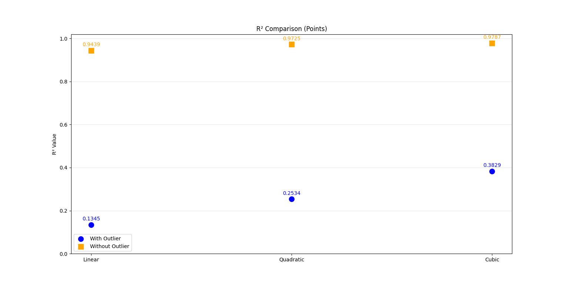
R² Comparison
Figure 16: R-square Comparison between three Models
Model | Parameters | R² (Original) → R² (Cleaned) | Gain in R² (Original) → Gain in R² (Cleaned)
Linear | 2 | 0.1345 → 0.9439 | —
Quadratic | 3 | 0.2534 → 0.9725 | +0.1189 → +0.0286
Cubic | 4 | 0.3829 → 0.9787 | +0.1295 → +0.0062
Conclusion (with outlier):
- Linear → Quadratic: R² gain = 0.1189 (significant) → Quadratic is better.
- Quadratic → Cubic: R² gain = 0.1295 (significant) → Cubic is better.
Best-fit model (with outlier): Cubic ŷ = 13113.15 – 4313.93 x + 932.31 x² – 58.95 $x^{3}$ (R² = 0.3829)

Conclusion (without outlier):
- Linear → Quadratic: R² gain = 0.0286 (significant) → Quadratic is better.
- Quadratic → Cubic: R² gain = 0.0062 → gain is NOT significant enough.
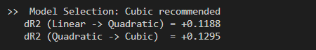
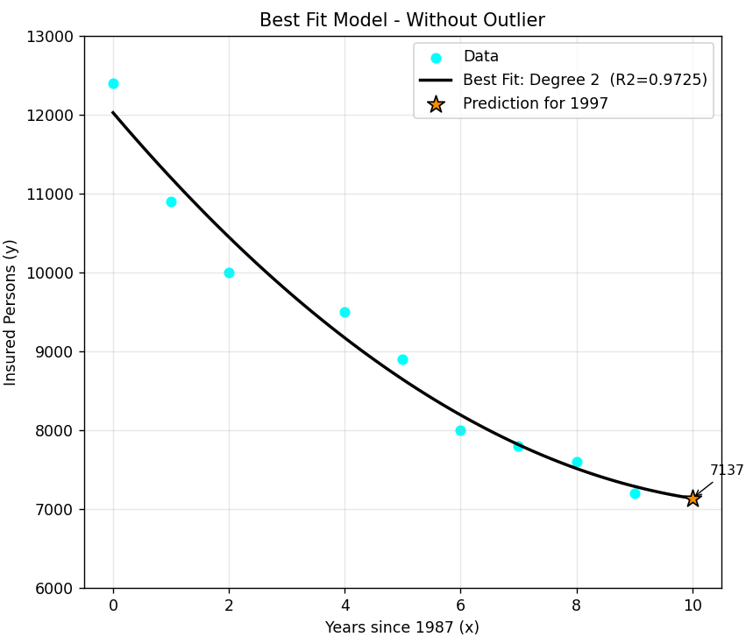
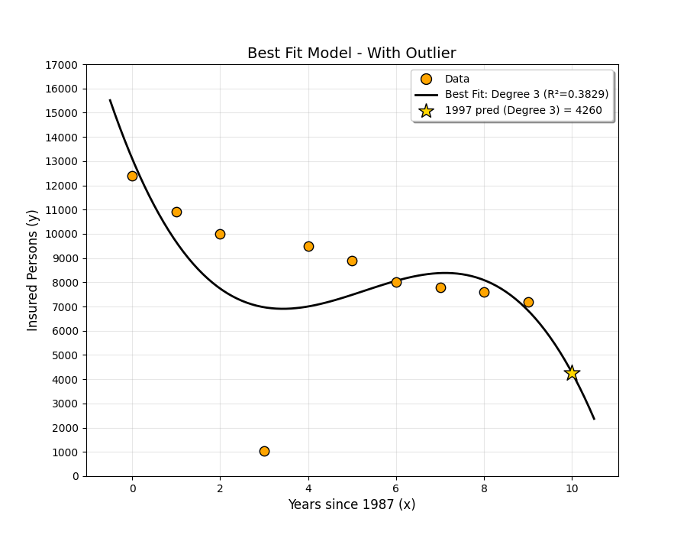
Best-fit model (without outlier): Quadratic ŷ = 12,024.17 − 863.13 x + 37.44 x² (R² = 0.972)
Figure 17: Best Fit Model with Outlier
Figure 18: Best Fit Model without Outlier
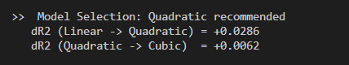
Figure 19: Simulation Results of Best Fit Model with Outlier

Figure 20: SImulation Results of Best Fit Model without Outlier

1.5 Prediction of Insured People
At year 1997 (x=10) :
- Using the best-fit model from the original data with outlier (Cubic model as selected):
$$\hat{y_{i}}=13113.15-4313.93 x_{i}{ + 932.31 x}_{i}^{2} {- 58.95 x}_{i}^{3}$$
ŷ = 13113.15 − 4313.93(10) + 932.31(10²) − 58.95(10³)= 4,254.85
Insured People ≈ 4,254.85 insured person

- Using the best-fit model from the cleaned data without outlier (Quadratic model as selected):
$$\hat{y_{i}}=12,024.17 -863.13 x+37.44 x^{2}$$
ŷ = 12,024.17 − 863.13(10) + 37.44(10²) = 7,136.87
Insured People ≈ 7,136.87 insured person
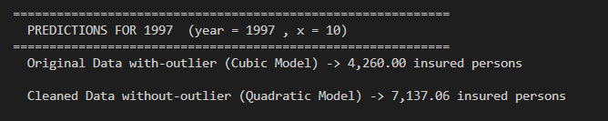
Figure 21: Simulation Results of Predection Insured People at year 1997

Problem 2: Heating Oil
We develop a regression model to estimate heating oil usage for a single-family home in January, based on two predictors: average temperature (Temp, in °F) and amount of insulation (Insulation, in inches).

2.1 Dataset
Oil (gallons) | Temp (°F) | Insulation (in)
270 | 40 | 4
362 | 27 | 4
162 | 40 | 10
45 | 73 | 6
91 | 65 | 7
233 | 65 | 40 ← OUTLIER
372 | 10 | 6
305 | 9 | 10
234 | 24 | 10
122 | 65 | 4
25 | 66 | 10
210 | 41 | 6
450 | 22 | 4
325 | 40 | 4
52 | 60 | 10

2.2 Case A: WITH Outlier

1. Scatter Plot & Outlier Identification
A 3D scatter plot of Oil Usage vs. Temperature and Insulation reveals that one data point is far outside the cluster formed by the other observations: the point (Temp=65°F, Insulation=40 in, Oil=233 gallons). All other insulation values range from 4 to 10 inches; an insulation thickness of 40 inches is physically unreasonable for a typical single-family home and is almost certainly a data entry error (e.g., the value 4 recorded as 40). This point is identified as the outlier and is highlighted in red in the scatter plot below.
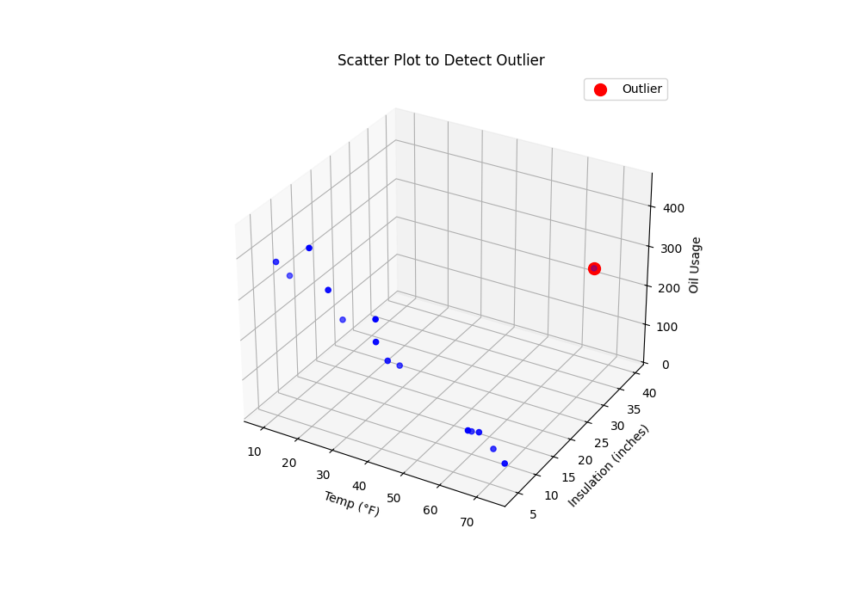
Figure 22: 3D Scatter Plot to Detect Outlier (outlier in red: Insulation=40)

2. Regression Models

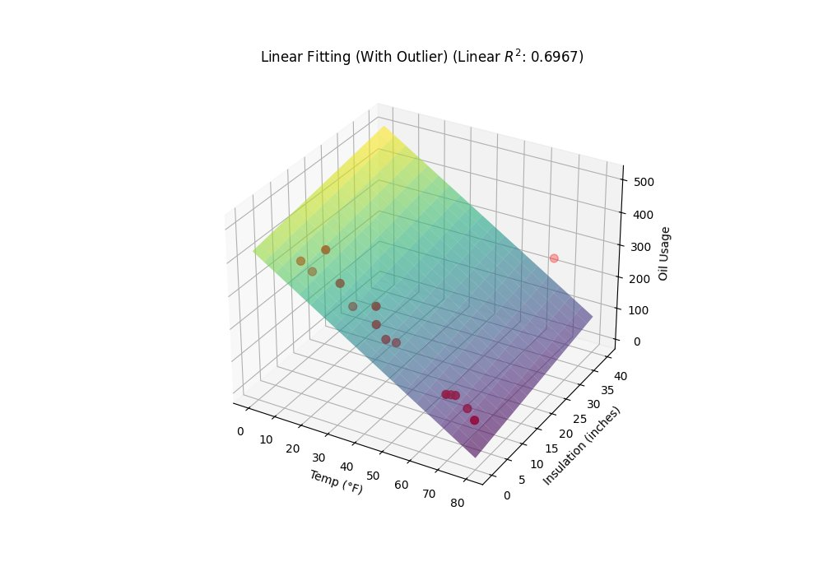
2.1 Linear Model
Figure 23: 3D Linear Regression Surface (With Outlier), R² = 0.6967
The multivariate linear model has the form:
$$Oil=β_{0}+β_{1}* T +β_{2}* I$$
where T = Temp, I = Insulation
$$Oil=426.97 - 5.274*T +1.966*I$$

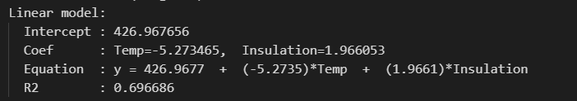
Figure 24: Simulation Results of Linear Regression Surface (With Outlier)

So, the linear fit equation for the original dataset is:

$$\hat{y_{i}}=426.97- 5.27x_{1i}+1.966 x_{2i}$$

The Coefficient of Determination (R²):
R² (Linear, With Outlier) = 0.6967

2.2 Quadratic Model
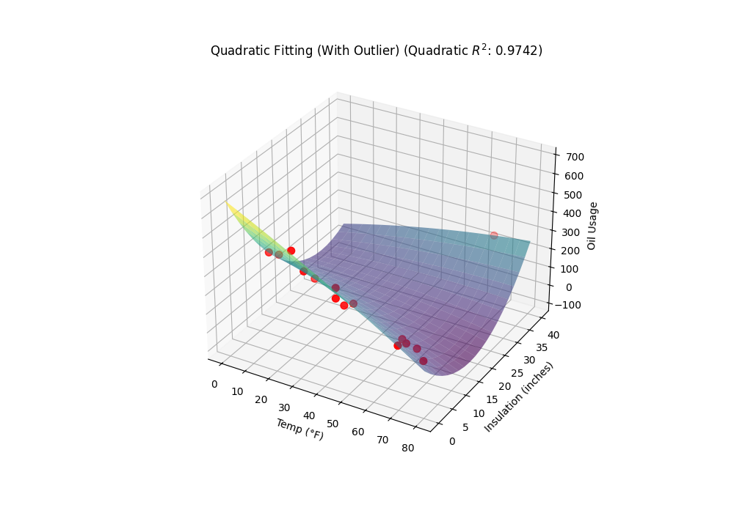
Figure 25: 3D Quadratic Regression Surface (With Outlier), R² = 0.9742
The multivariate linear model has the form:
$$Oil=β_{0}+β_{1} T +β_{2} I +β_{3}T^{2}+β_{4}TI+β_{5}{ I}^{2}$$
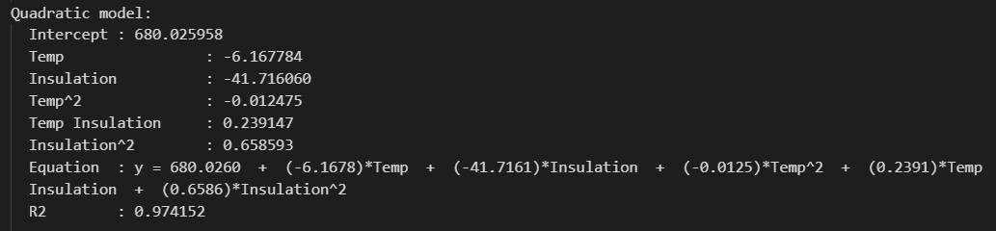
where T = Temp, I = Insulation
Figure 26: Simulation Results of Quadratic Regression Surface (With Outlier)
$$Oil=680.03 - 6.168 T - 41.716 I - 0.01248 T^{2}+0.2392 TI+0.6586{ I}^{2}$$
So, the quadratic fit equation for the original dataset is:
$$\hat{y_{i}}=680 - 6.17x_{1i}-41.72 x_{2i}- 0.012 x_{1i}^{2}+0.24 x_{1i}x_{2i}+0.66 x_{2i}^{2}$$
The Coefficient of Determination (R²):
R² (Quadratic, With Outlier) = 0.9742

2.3 Case B: WITHOUT Outlier

1. Scatter Plot & Outlier Identification (WITHOUT Outlier)
The data point (Temp=65, Insulation=40, Oil=233) is removed. All remaining 14 data points have insulation values between 4 and 10 inches, which is physically reasonable. The cleaned scatter plot is shown below.
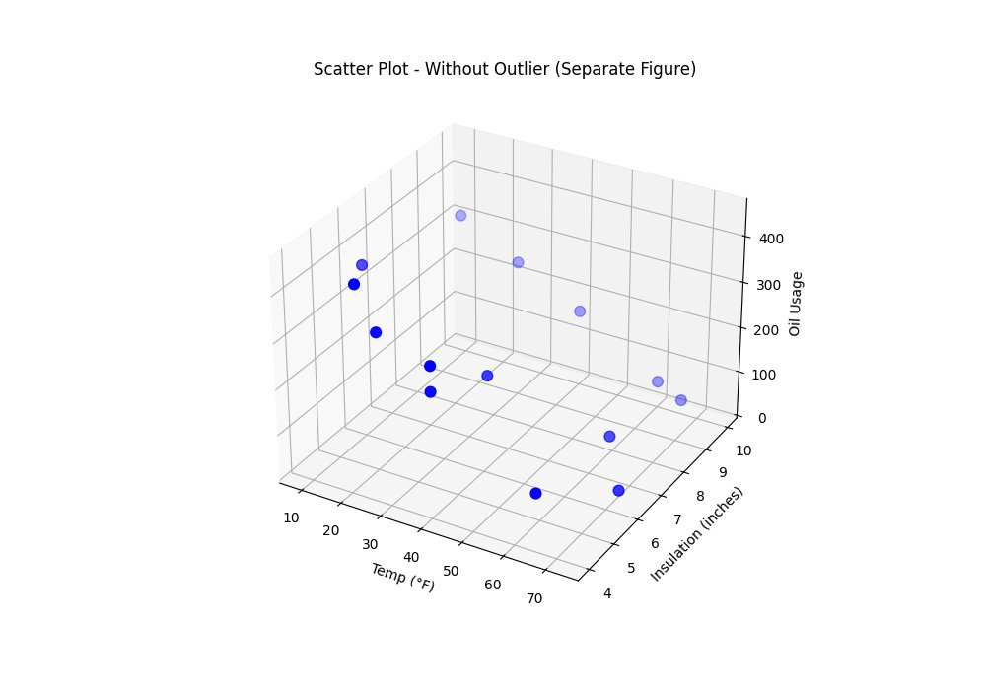
Figure 27: 3D Scatter Plot (Cleaned Data, Outlier Removed)

2. Regression Models (WITHOUT Outlier)

2.1 Linear Model
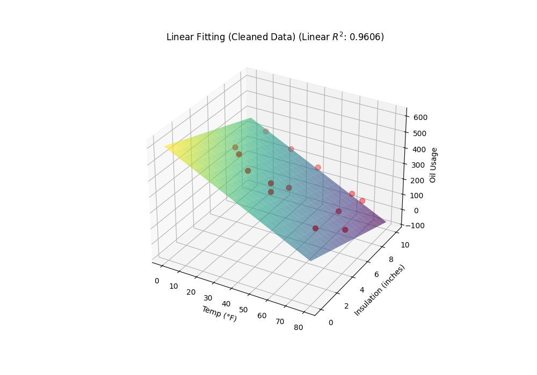
Figure 28: 3D Linear Regression Surface (Cleaned Data), R² = 0.9606
The multivariate linear model has the form:
$$Oil=β_{0}+β_{1}* T +β_{2}* I$$
where T = Temp, I = Insulation
$$Oil=601.6 - 5.482 T - 23.232 I$$

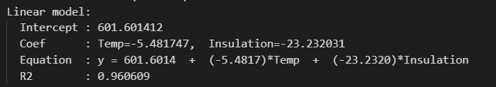
Figure 29: Simulation Results of Linear Regression Surface (Cleaned Data)

So, the linear fit equation for the original dataset is:

$$\hat{y_{i}}=601.6- 5.482 x_{1i}+23.232 x_{2i}$$

The Coefficient of Determination (R²):

R² (Linear, With Outlier) = 0.96061

2.2 Quadratic Model
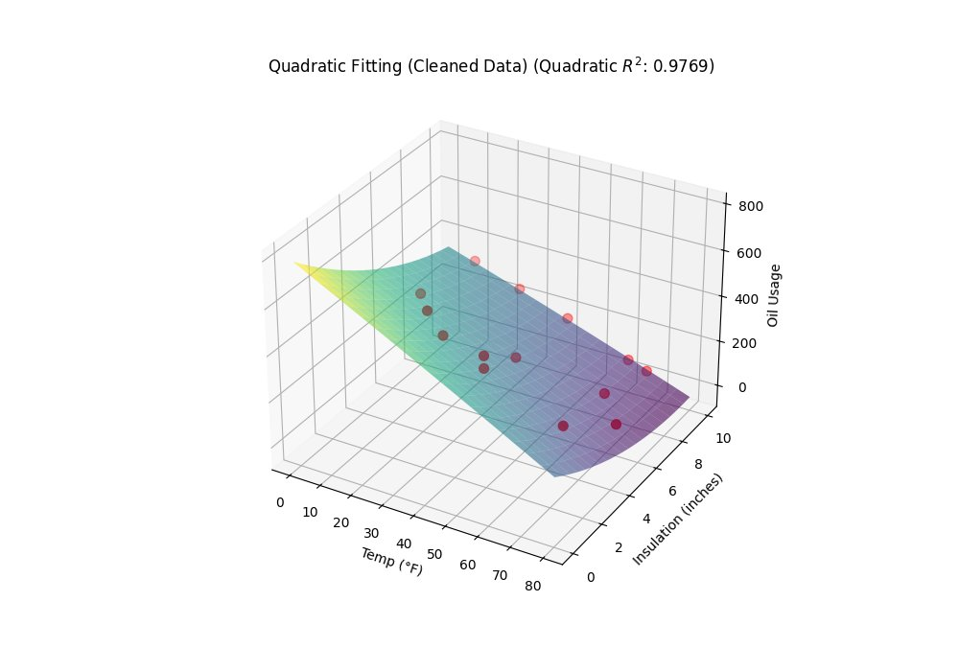
Figure 30: 3D Quadratic Regression Surface (Cleaned Data), R² = 0.9769
The multivariate quadratic model has the form:
$$Oil=β_{0}+β_{1} T +β_{2} I +β_{3}T^{2}+β_{4}TI+β_{5}{ I}^{2}$$
where T = Temp, I = Insulation
$$Oil=785.52- 6.963 T - 72.159 I - 0.00348 T^{2}+0.2567 TI+2.7438{ I}^{2}$$

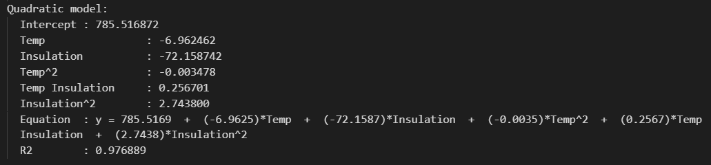
Figure 31: Simulation Results of Quadratic Regression Surface (Cleaned Data)

So, the linear fit equation for the original dataset is:

$$\hat{y_{i}}=785.52 - 6.963 x_{1i}-72.159 x_{2i}- 0.00348 x_{1i}^{2}+0.2567 x_{1i}x_{2i}+2.7438 x_{2i}^{2}$$

The Coefficient of Determination (R²):
R² (Quadratic, With Outlier) = 0.9769

2.4 Comparison of Models and Best-Fit Selection

Model | R² (With Outlier) | R² ² (Without Outlier) | Gain (With Outlier) | Gain ² (Without Outlier)
Linear | 0.6967 | 0.9606 | — | —
Quadratic | 0.9742 | 0.9769 | +0.2775 | +0.0163

Conclusion (Part a — With Outlier):
Linear → Quadratic gain = +0.2775
Best-fit model (with outlier): Quadratic (R² = 0.9742).
Conclusion (Part b — Without Data):
Linear → Quadratic gain = +0.0163 (NOT significant enough).
Best-fit model (without outlier): Linear (R² = 0.9606).

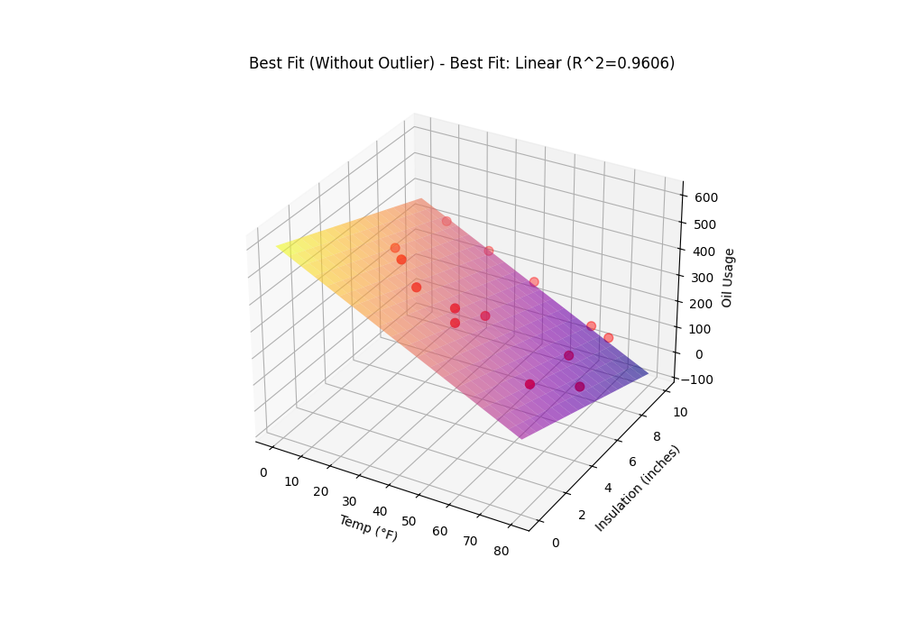
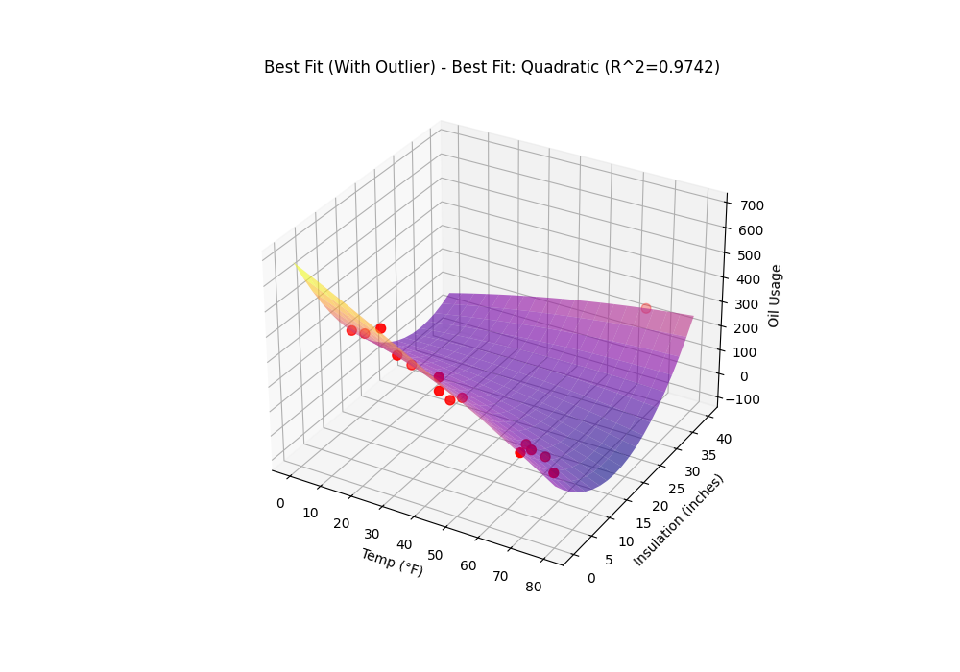
After removing the outlier, the linear model already achieves R² = 0.9606. The gain from linear to quadratic is only +0.0163, which is NOT significant enough as specified in Note 4 of the assignment.
Figure 32: Best Fit Model of Cleaned Data (Linear Model)
Figure 33: Best Fit Model of Original Data (Quadratic Model)
- Simulation Results:

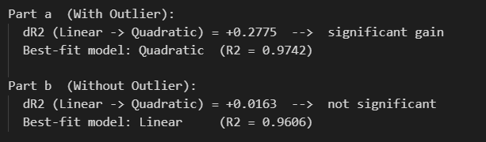
Figure 34: Simulation Results of Best Fit Model

2.5 Prediction of Oil
Temp =15°F, Insulation = 5 inches
The linear model could be abstracted as follows:
ŷᵢ = β₀ + β₁x₁ᵢ + β₂x₂ᵢ
Linear Model | Data with Outlier | Data without Outlier  (Best Fit)
β₀ | 427 | 601.6
β₁ | - 5.273 | - 5.482
β₂ | 1.966 | - 23.23
R² | 0.6966 | 0.9606
ŷ(temp = 15, insulation = 5) | 357.7 | 403.22
- Using the best-fit model from the cleaned data without outlier (Linear model as selected):
Oil = 601.60 − 5.482 * 15 − 23.232 * 5 = 403.21
Predicted Oil Usage ≈ 403.2 gallons

- Simulation Results:
Figure 35: Simulation Results of Prediction Oil of Cleaned Data

The quadratic model could be abstracted as follows:
ŷᵢ = β₀ + β₁x₁ᵢ + β₂x₂ᵢ + β₃x₁²ᵢ + β₄x₁ᵢx₂ᵢ + β₅x₂²ᵢ
Linear Model | Data with Outlier  (Best Fit) | Data without Outlier
β₀ | 680 | 785.5
β₁ | - 6.17 | - 6.96
β₂ | - 41.72 | - 72.16
β₃ | - 0.012 | - 0.0034
β₄ | 0.24 | 0.2567
β₅ | 0.66 | 2.744
R² | 0.9741 | 0.9768
ŷ(temp = 15, insulation = 5) | 410.52 | 407.35

- Using the best-fit model from the original data with outlier (Quadratic model as selected):
Oil = 680 + (−6.17)(15) + (−41.72)(5) + (−0.012)(15²) + (0.24)(15)(5) + (0.66)(5²) = 410.65
Predicted Oil Usage ≈ 410.65 gallons

- Simulation Results:
Figure 36: Simulation Results of Prediction Oil of Original Data

